Darkly (pvictor)

# Hack 1: MD5 cookies

Change the value of the cookies i_am_admin to b326b5062b2f0e69046810717534cb09 (aka true in md5, instead of false as previsous value)

**df2eb4ba34ed059a1e3e89ff4dfc13445f104a1a52295214def1c4fb1693a5c3**

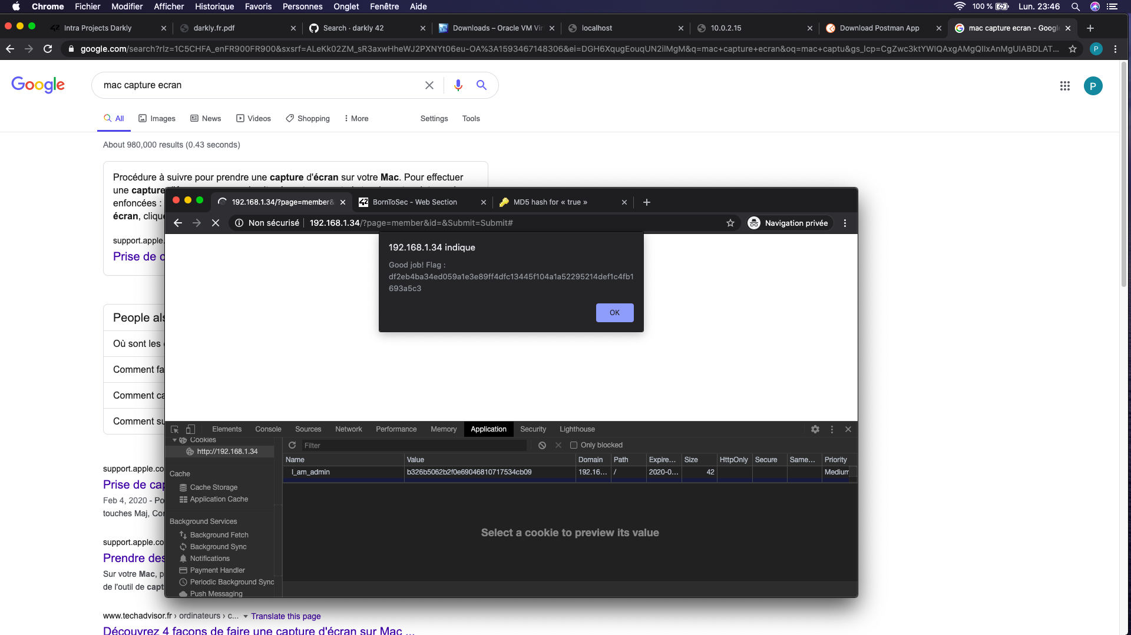

# Hack 2: Option tempering

Change the value of the option in the survey to some random number (it has to be numbers, no strings) and submit the corresponding option.

* The data from the users should be tested.

THE FLAG IS 03A944B434D5BAFF05F46C4BEDE5792551A2595574BCAFC9A6E25F67C382CCAA

# Hack 3: Robots.txt

About Robot.txt : <https://support.google.com/webmasters/answer/6062596?hl=en>

Robots.txt gives rules to google bots about which files

1. Go to <ip>/robots.txt

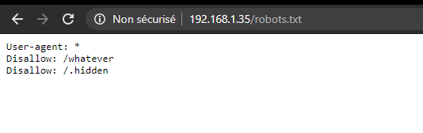

1. Go to /whatever

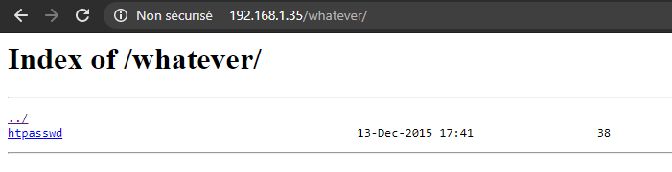

1. Download htpasswd

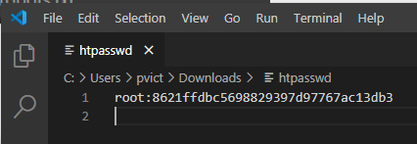

1. Put the password on google: it’s md5 for “dragon”
2. Go to <ip>/admin and connect with root / dragon

THE FLAG IS d19b4823e0d5600ceed56d5e896ef328d7a2b9e7ac7e80f4fcdb9b10bcb3e7ff

# Hack 4: Reset password

1. Go to recover password: <ip>/index.php?page=recover#
2. Inspect the submit button

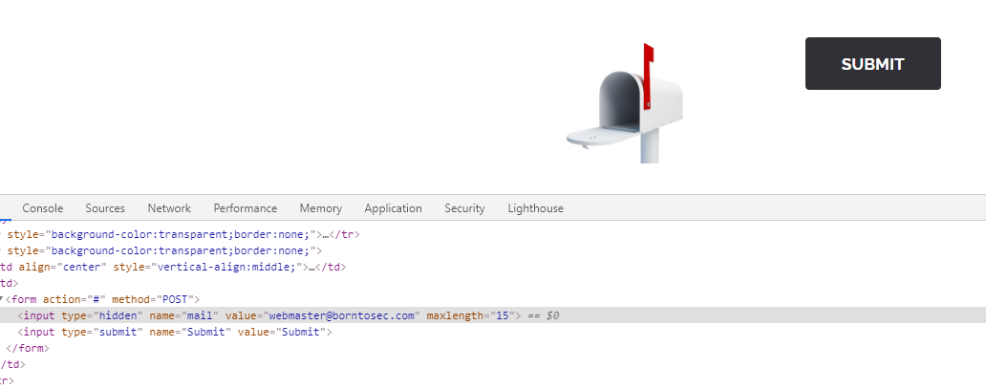

1. Change the value of the email

THE FLAG IS 1D4855F7337C0C14B6F44946872C4EB33853F40B2D54393FBE94F49F1E19BBB0

# Hack 5: JS Injection

Go to the feedback section, and enter “script” in the comment section

THE FLAG IS : 0FBB54BBF7D099713CA4BE297E1BC7DA0173D8B3C21C1811B916A3A86652724E

# Hack 6: Changing the value of a link

1. Go to the main page
2. Scroll down to the social network links
3. Inspect one and change its href (param “site”)

The flag is : B9E775A0291FED784A2D9680FCFAD7EDD6B8CDF87648DA647AAF4BBA288BCAB3

# Hack 7: SQL injection image search

1. Go to the search image page
2. In the input field, put “1 or 1=1 UNION select table_name, column_name FROM information_schema.columns” in order to get information about the tables from the db
3. We get the following information about the list_images table

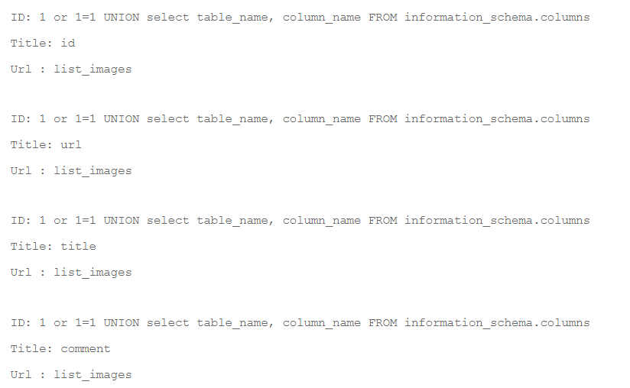

1. We put “1 or 1=1 UNION select url, comment from list_images”



1. We obey: use Google to decode (🡺 “albatroz”), then sha256

The flag is: f2a29020ef3132e01dd61df97fd33ec8d7fcd1388cc9601e7db691d17d4d6188

# Hack 8: SQL injection user search

1. Go to the search member page
2. In the input field, put “1 or 1=1 UNION select table_name, column_name FROM information_schema.columns” in order to get information about the tables from the db
3. We get the following information about the users table

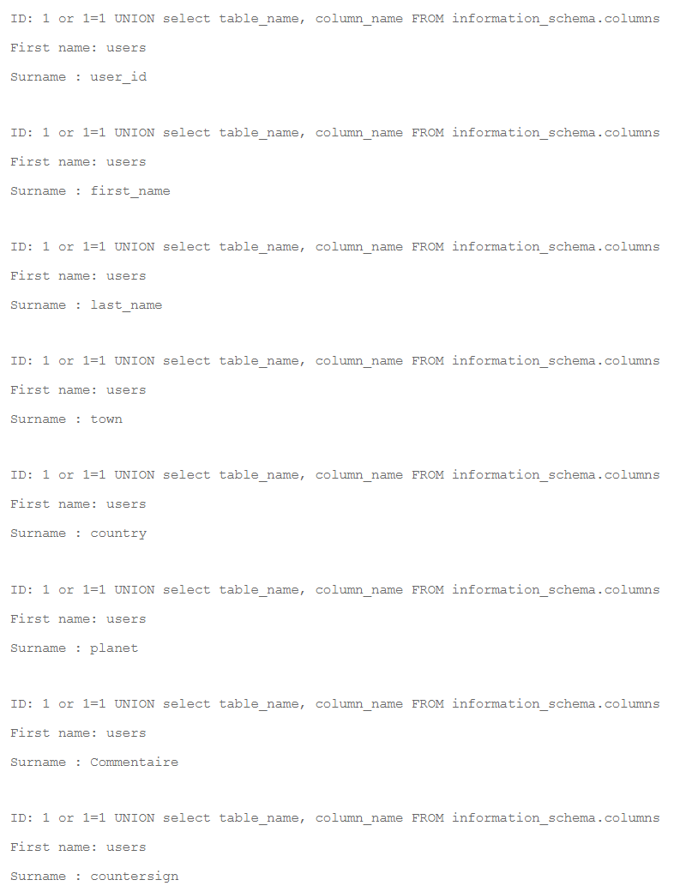

1. We try all the couples and finally we put “1 or 1=1 UNION select Commentaire, countersign from users” and get this:

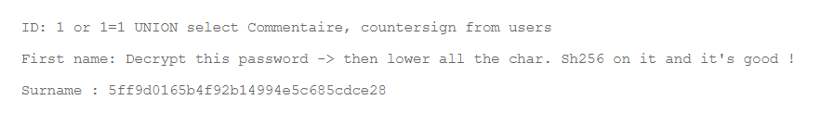

1. When entered on Google, 5ff9d0165b4f92b14994e5c685cdce28 appears to be MD5 for “FortyTwo”. “fortytwo” converted to SHA256 is 10a16d834f9b1e4068b25c4c46fe0284e99e44dceaf08098fc83925ba6310ff5, which seems to be the flag.

# Hack 9: Browsing files

1. When we go to the search member page, we see that the URL is: http://192.168.1.35/?page=member
2. This means there is no router and we might be able to browse files. We try to go to the /etc/passwd file, which does not work: http://192.168.1.35/?page=etc/passwd
3. When we go one folder higher, the message changes, and it changes again until we get it right.
4. The right path is: http://192.168.1.35/?page=../../../../../../../etc/passwd

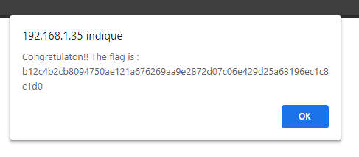

The flag is: b12c4b2cb8094750ae121a676269aa9e2872d07c06e429d25a63196ec1c8c1d0

# Hack 10: Browsing files (again)

1. When we went to <ip>/robots.txt, we discovered the /.hidden path
2. It contains about 30 folders, containing each about 30 subfolders, each with a README file.
3. After opening about 70, I decided to do a php script to find the right one. Start the php server (“php -S localhost:8089 -t .”) and go to <http://localhost:8089>.
4. Click on the link to start the script.

# Hack 11: Redirection

1. Again with the “page=” URL : we try <http://192.168.1.35/?page=redirect>. We arrive on a blank page, so this seems to exist.
2. We then add a “site” parameter: “http://192.168.1.35/?page=redirect&site=42”

The flag is: B9E775A0291FED784A2D9680FCFAD7EDD6B8CDF87648DA647AAF4BBA288BCAB3

# Hack XX: image

var test = "<script>alert('42');</script>"

btoa(test); 🡺 "PHNjcmlwdD5hbGVydCgnNDInKTs8L3NjcmlwdD4="

# Hack XX – password brut force

nmap

<https://null-byte.wonderhowto.com/how-to/brute-force-ssh-ftp-vnc-more-with-brutedum-0197449/>

Try Vega ?

# Hack XX: SQL Injections

Write "<script>alert("loser");</script> in Search Members

We know that the field is not protected against SQL Injections

# Key takeways from the project

* No hash values in cookies (use jwt instead)